Object Oriented Analysis and Design with Java Week 8 -Lab

Name: - Adithya M

SRN: - PES2UG19CS015

Section: - A

1)

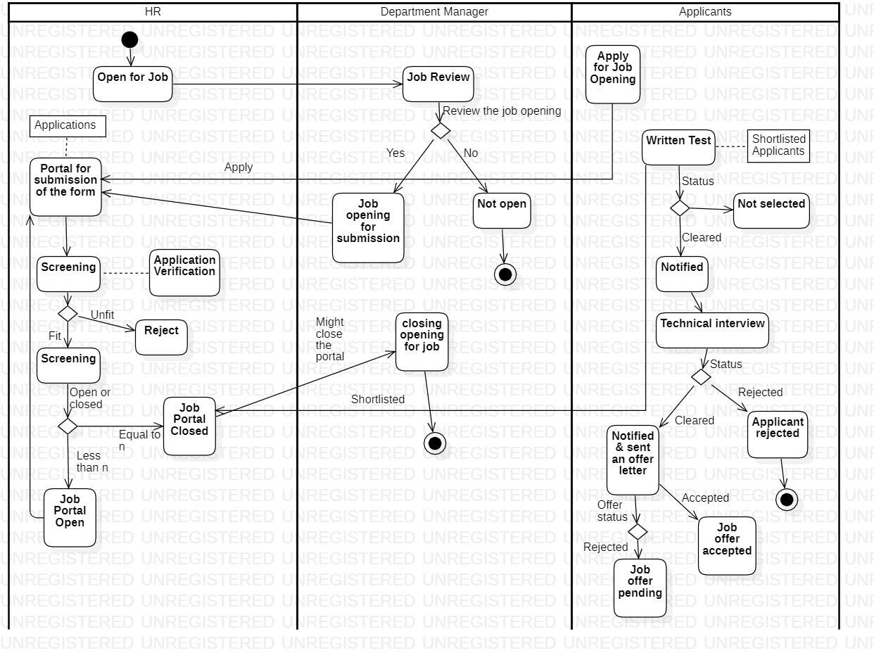

**2a)**

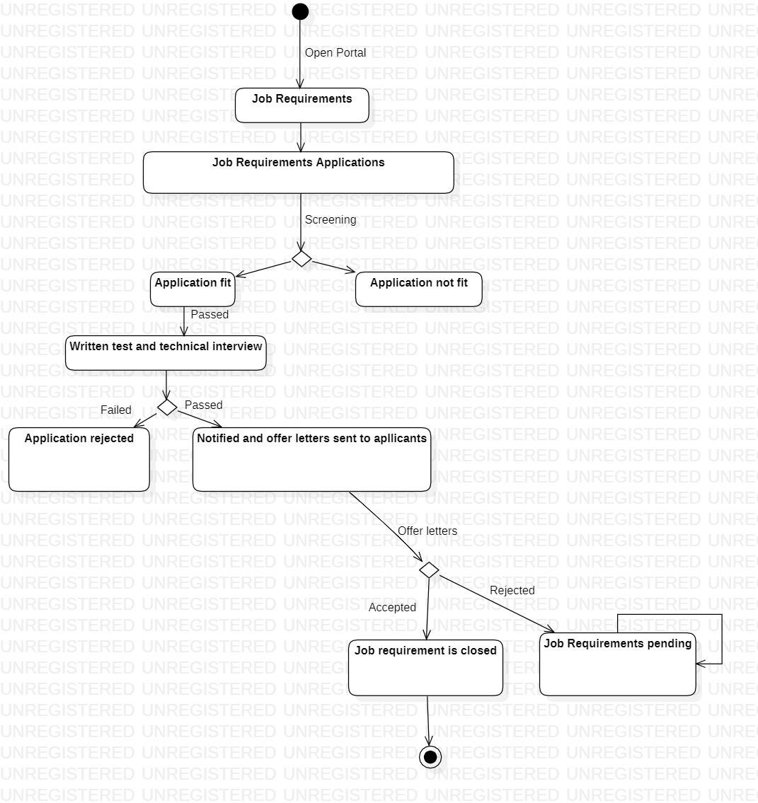

**2b)**

